For research article
Response to Reviewer 2 Comments
Point-by-point response to Comments and Suggestions for Authors
Comments 1: The Abstract introduces the research purpose for too long and should include quantitative evaluation results.
Response 1: Thank you for your insightful and valuable feedback. In response to your suggestion, we have streamlined the abstract and incorporated key quantitative experimental results. The revised abstract is as follows:
Location in the revised manuscript:
Page 1, Abstract, Lines 3–18. Specifically, the condensed research motivation is provided in Lines 3–5, while the revised method summary and quantitative evaluation results are presented in Lines 13–18.
Revised manuscript text:
“Abstract
Hyperspectral image (HSI) clustering assigns unlabeled pixels to land-cover groups by jointly exploiting spectral and spatial observations. Existing Vision Transformer-based deep clustering captures global dependencies through self-attention. However, the quadratic computational complexity of self-attention restricts practical applications in large HSI scenes. Furthermore, illumination variation and topographic shading shift spectral amplitude of co-class pixels toward divergent directions in feature space, enlarging intra-class distances and reducing inter-class separability in learned embeddings. To address the above limitations, we propose a self-supervised Spatial--Frequency Interaction and Amplitude-Phase Decoupling framework, termed SFI-APD, which integrates a High-Order Spatial-Frequency Interaction Module (HSFIM), a Frequency Feature Attention Block (FFAB), and a Frequency-Domain Vision Transformer (FreqViT) into a unified architecture. Specifically, HSFIM couples local convolutions with Fourier filtering to extract enriched spectral-spatial representations. FFAB then decouples amplitude and phase components to suppress brightness variations, yielding illumination-robust embeddings. Finally, FreqViT performs attention modulation across spectral channels, reducing token aggregation complexity from $O(N^{2}D)$ to $O(NDlogN)$. On the Indian Pines, Salinas, Pavia University, and Yangzhou datasets, SFI-APD achieves OAs of 57.47%, 79.38%, 54.57%, and 64.11%, respectively, outperforming state-of-the-art self-supervised methods for large HSIs.
Keywords: Hyperspectral image clustering; multi-domain fusion; frequency-domain feature attention; amplitude-phase decoupling; Vision Transformer”

Comments 2: What is the relationship between Stage 1 and Stage 2 in Figure 1? Meanwhile, some variables in the figure are not represented in italics.
Response 2: Thank you very much for your careful observation and correction. The original manuscript does not explain the relationship between Stage 1 and Stage 2 clearly enough, which may make the transition between the two stages difficult to follow. Therefore, we have added the corresponding description in the manuscript.
Stage 1 and Stage 2 are trained in sequence.In Stage 1, the autoencoder is pretrained with reconstruction loss to learn data features and initialize the feature extractor for the next clustering stage.In Stage 2, the features extracted by the autoencoder are used to initialize the cluster centers with k-means. Then, the DEC clustering algorithm initializes the cluster centers and performs iterative optimization using the KL divergence between the target distribution and the soft assignment distribution.And the final cluster assignments are obtained from the optimized soft assignments.In addition, the loss formulas and related symbols in the overall architecture diagram have been updated to italic format. The notation is now consistent with the equations in the main text, improving the clarity and consistency of the layout.
Location in the revised manuscript:
Section 3.1, Overall Architecture, immediately after the paragraph ending with “pixel-wise cluster assignments” and immediately before Figure 1. The revised overall architecture diagram remains Figure 1.
Revised manuscript text:

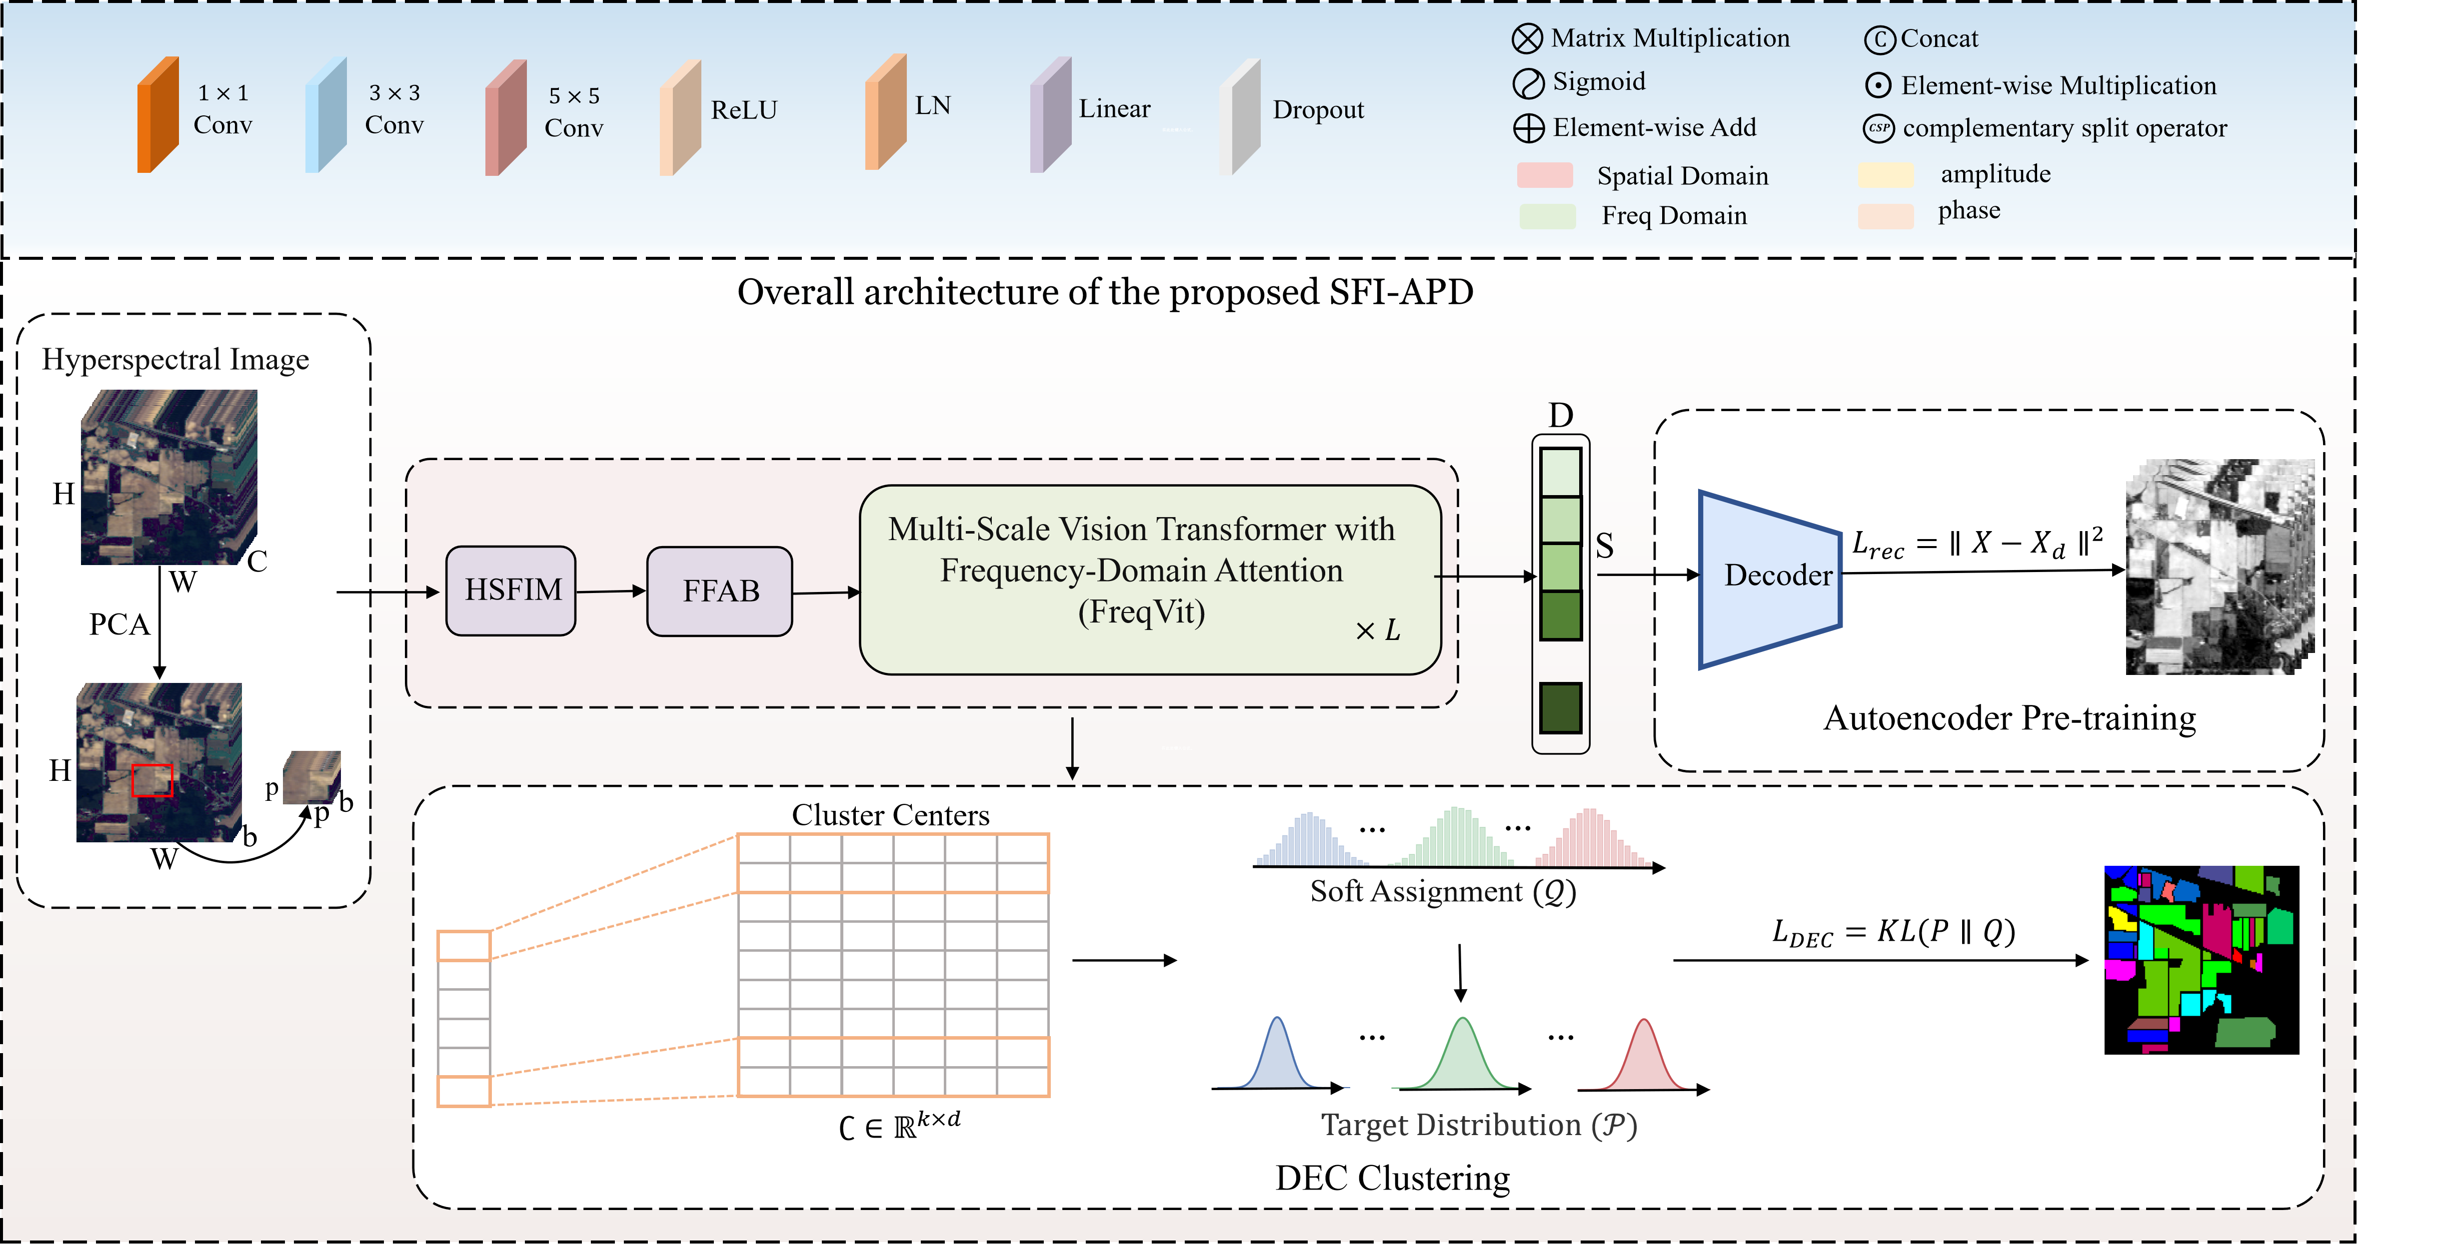
“Figure 1. Overall architecture of the SFI-APD framework. Firstly, the High-order space-frequency interactive module (HSFIM) was used to fuse the space-frequency features of the hyperspectral image after PCA dimension reduction. Then frequency feature Attention Block (FFAB) decouples the features fused with spatial-frequency information from amplitude and phase to suppress the spectral distortion caused by illumination and retain structural information. Finally, the Frequency Domain Vision Transformer (FreqViT) captures long-range dependencies under a self-supervised optimization strategy for feature representation learning with clustering optimization.”

Location in the revised manuscript:
Section 4.1.4, Implementation Details, replacing the existing paragraph beginning with “Training contains two stages.”
Revised manuscript text:
“The training is performed in two consecutive stages. In Stage 1, the autoencoder is pretrained to minimize the reconstruction loss using the Adam optimizer with a learning rate of $1×10^{−3}$. The number of pretraining rounds for the IP, SA, PU, and YZ datasets is set to 200, 300, 600, and 800, respectively. Stage 1 initializes the encoder and decoder weights and enables the network to learn preliminary feature representations with spectral-spatial structure. In Stage 2, the encoder and decoder weights pretrained in Stage 1 are used to initialize the clustering network. The encoder extracts latent features from the input data, and k-means is applied to initialize the cluster centers. The DEC-based clustering algorithm then iteratively updates the latent feature representation and cluster centers by minimizing the KL divergence between the target distribution P and the soft assignment distribution Q, with the degree-of-freedom parameter in Student's t-distribution fixed at α=1 for all datasets.The clustering loss weight is set to 1.0, and the learning rate is set to $1×10^{−4}$. All experiments were implemented using PyTorch on an NVIDIA GeForce RTX 4090 GPU.”
Comments 3: Many frequency-domain Vision Transformers have been proposed. Please supplement the relevant research in Related Work and explain the advantages of the proposed FreqViT compared with existing methods.
Response 3: We sincerely thank the reviewers for providing the insightful feedback.We fully agree that previous discussions on frequency domain vision transformers are indeed insufficient and need to be further deepened; In particular, it is necessary to clarify the essential differences between FreqViT and existing related methods in terms of technical path, modeling mechanism, and design motivation. In the revised manuscript, we have expanded the Related Work section by incorporating several representative frequency-domain token-mixing and attention mechanisms, including FNet[38], GFNet[39], DCT-based attention[40], and FFTformer-FSAS[41], in addition to the previously discussed AFNO[16], Wave-ViT[17], and SpectFormer.[18] We now categorize these methods according to their underlying core mechanisms—including parameter-free token mixing, global spectral filtering, frequency-domain truncation, and dot-product approximation. We further provide an explicit and detailed exposition of FreqViT’s technical advantages relative to these baseline approaches.Unlike methods that rely on fixed spectral mixing or retain selected frequency components, FreqViT explicitly computes input-adaptive query-key correlations through normalized cross-spectrum modulation.The proposed cross-spectrum modulation preserves query-key dependencies and replaces the dense $N×N$ affinity matrix, yielding a token aggregation complexity of $O(ND\log{N})$.Existing frequency-domain architectures primarily target generic visual recognition or supervised restoration. To address self-supervised HSI clustering, FreqViT introduces amplitude-phase decoupling, which effectively manages illumination variations and long-range spectral-spatial dependencies.

References:
[16]J. Guibas, M. Mardani, Z. Li, A. Tao, A. Anandkumar, and B. Catanzaro, “Adaptive Fourier neural operators: Efficient token mixers for Transformers,” Proc. ICLR, 2022.
[17] Wave-ViT
T. Yao, Y. Pan, Y. Li, C.-W. Ngo, and T. Mei, “Wave-ViT: Unifying wavelet and Transformers for visual representation learning,” Proc. ECCV, 2022, pp. 328–345.
[18] SpectFormer B. N. Patro, V. P. Namboodiri, and V. S. Agneeswaran, “SpectFormer: Frequency and attention is what you need in a Vision Transformer,” Proc. WACV, 2025, pp. 9543–9554.
[38] J. Lee-Thorp, J. Ainslie, I. Eckstein, and S. Ontanon, “FNet: Mixing tokens with Fourier transforms,” Proc. NAACL, 2022, pp. 4296–4313.
[39] Y. Rao, W. Zhao, Z. Zhu, J. Lu, and J. Zhou, “Global filter networks for image classification,” Advances in Neural Information Processing Systems, vol. 34, 2021, pp. 980–993.
[40] H. Pan, E. Hamdan, X. Zhu, K. Biswas, A. E. Cetin, and U. Bagci, “DCT-based decorrelated attention for vision Transformers,” arXiv preprint arXiv:2405.13901, 2024.
[41] L. Kong, J. Dong, J. Ge, M. Li, and J. Pan, “Efficient frequency domain-based Transformers for high-quality image deblurring,” Proc. CVPR, 2023, pp. 5886–5895.

Location in the Revised Manuscript
Section 2.2, “Vision Transformer,” in the Related Work section, specifically the final paragraph of this subsection, immediately before Section 3, “Method.”
Revised Manuscript Text
“Frequency-domain and wavelet-based ViT architectures present an alternative paradigm for efficient token mixing. AFNO employs adaptive Fourier-domain token mixing for high-resolution Vision Transformers via block-diagonal channel mixing, adaptive weight sharing, and sparse frequency modes[16] . Wave-ViT integrates wavelet transforms into Vision Transformer attention, leveraging invertible key-value downsampling to retain high-frequency texture details[17]. SpectFormer combines multi-head attention with spectral layers that transform image tokens into the Fourier domain and recover spatial tokens through inverse Fourier transforms[18]. Earlier Fourier token mixers, such as FNet, substitute self-attention with parameter-free Fourier transforms, whereas GFNet formulates global frequency filters to capture long-range spatial dependencies[38-39] . DCT-based attention leverages frequency decorrelation and high-frequency component truncation to mitigate computational overhead, whereas FFTformer-FSAS approximates scaled dot-product attention via element-wise multiplication in the frequency domain[40-41].
Rather than relying on fixed spectral mixing or rigid frequency filtering, FreqViT computes input-adaptive query-key correlations via normalized cross-spectrum modulation. This avoids constructing a dense N×N affinity matrix, successfully preserving token dependencies while reducing aggregation complexity from from $O(N²D)$ to $O(NDlogN)$. Furthermore, while conventional frequency-domain models target generic vision tasks, FreqViT explicitly integrates amplitude-phase decoupling. The design allows the model to capture long-range spectral-spatial dependencies and robustly handle illumination variations in self-supervised HSI clustering.”
References:
[16]J. Guibas, M. Mardani, Z. Li, A. Tao, A. Anandkumar, and B. Catanzaro, “Adaptive Fourier neural operators: Efficient token mixers for Transformers,” Proc. ICLR, 2022.
[17] Wave-ViT
T. Yao, Y. Pan, Y. Li, C.-W. Ngo, and T. Mei, “Wave-ViT: Unifying wavelet and Transformers for visual representation learning,” Proc. ECCV, 2022, pp. 328–345.
[18] SpectFormer B. N. Patro, V. P. Namboodiri, and V. S. Agneeswaran, “SpectFormer: Frequency and attention is what you need in a Vision Transformer,” Proc. WACV, 2025, pp. 9543–9554.
[38] J. Lee-Thorp, J. Ainslie, I. Eckstein, and S. Ontanon, “FNet: Mixing tokens with Fourier transforms,” Proc. NAACL, 2022, pp. 4296–4313.
[39] Y. Rao, W. Zhao, Z. Zhu, J. Lu, and J. Zhou, “Global filter networks for image classification,” Advances in Neural Information Processing Systems, vol. 34, 2021, pp. 980–993.
[40] H. Pan, E. Hamdan, X. Zhu, K. Biswas, A. E. Cetin, and U. Bagci, “DCT-based decorrelated attention for vision Transformers,” arXiv preprint arXiv:2405.13901, 2024.
[41] L. Kong, J. Dong, J. Ge, M. Li, and J. Pan, “Efficient frequency domain-based Transformers for high-quality image deblurring,” Proc. CVPR, 2023, pp. 5886–5895.

Comments 4: The four datasets need to be supplemented with necessary citation annotations.
Response 4: Thank you very much for pointing out that the original manuscript did not provide sufficiently detailed references for the sources and acquisition conditions of the datasets. In the revised manuscript, we have expanded the description of each dataset by specifying its source reference, imaging sensor, acquisition location or conditions, and principal spatial and spectral characteristics. Specifically, the Indian Pines image and its acquisition record are provided by the Purdue University Research Repository [42]. The Indian Pines image was acquired by the Airborne Visible/Infrared Imaging Spectrometer (AVIRIS) over an agricultural area in northwestern Indiana, USA, and contains ($145×145$) pixels, a spatial resolution of 20 m, 200 retained spectral bands, and 16 land-cover classes. The Salinas image was acquired by AVIRIS over Salinas Valley, California, USA, and the AVIRIS imaging system and related acquisition information are described by Green et al. [43]. This image contains ($512×217$) pixels, has a spatial resolution of 3.7 m, and includes 204 spectral bands and 16 land-cover classes. The Pavia University image and its ROSIS-based acquisition setting are documented by Benediktsson et al. [44]. It was acquired over Pavia, Italy, and contains ($610×340$) pixels with a spatial resolution of 1.3 m, 103 retained spectral bands covering ($0.43−0.86 μm$), and 9 land-cover classes. The Yangzhou image was acquired over Yangzhou, China, using the Multi-Parameter Airborne Remote Sensing System (MARSS) at a flight altitude of 600 m. The dataset has a spatial resolution of 1.5 m, a size of ($956×365$) pixels, 249 continuous spectral bands, and 8 land-cover classes.
In addition, each reference has been placed immediately after the corresponding statement concerning the dataset source or acquisition information, rather than at the beginning of a sentence or only after the final description of the dataset. These revisions more clearly establish the provenance, acquisition conditions, and principal characteristics of the four datasets, thereby improving the clarity and reproducibility of the experimental setup. The corresponding revisions are presented below.
Reference:
[42] S. Tadjudin and D. A. Landgrebe, “Covariance estimation with limited training samples,” IEEE Trans. Geosci. Remote Sens., vol. 37, no. 4, pp. 2113–2118, Jul. 1999, doi: 10.1109/36.774728.
[43] G. Vane, R. O. Green, T. G. Chrien, H. T. Enmark, E. G. Hansen, and W. M. Porter, “The airborne visible/infrared imaging spectrometer (AVIRIS),” Remote Sens. Environ., vol. 44, nos. 2–3, pp. 127–143, May–Jun. 1993, doi: 10.1016/0034-4257(93)90012-M.
[44] J. A. Palmason, J. A. Benediktsson, and J. R. Sveinsson, “Classification of hyperspectral ROSIS data from urban areas,” in Proc. 2nd Int. Conf. Recent Advances in Space Technologies (RAST), Istanbul, Turkey, 2005, pp. 63–69, Art. no. 1512536, doi: 10.1109/RAST.2005.1512536.
[45] N. Huang, T. Wu, Q. Liu, P. Liu, K. Ni, Z. Zheng, and L. Xiao, “CNLTrans: A cluster-wise non-local Transformer for self-supervised deep clustering of large hyperspectral images,” IEEE J. Sel. Topics Appl. Earth Observ. Remote Sens., early access, 2026, doi: 10.1109/JSTARS.2026.3702236.

Location in the Revised Manuscript
Section 4.1.1, “Datasets,” paragraphs 1–4, containing the descriptions of the Indian Pines, Salinas, Pavia University, and Yangzhou datasets. The newly added reference [R3] is included in the References section.
Revised Manuscript Text
“Indian Pines (IP). IP was acquired by the Airborne Visible/Infrared Imaging Spectrometer (AVIRIS) over an agricultural area in northwestern Indiana, USA. The image contains ($145×145$) pixels with a spatial resolution of 20 m. After the removal of water-absorption and noisy bands, 200 spectral bands are retained. The reference map contains 16 land-cover classes [42].
Salinas (SA). SA was acquired by AVIRIS over Salinas Valley, California, USA. The image contains ($512×217$) pixels with a spatial resolution of 3.7 m. After the removal of water-absorption bands, 204 spectral bands are used. The reference map contains 16 land-cover classes [43].
Pavia University (PU). PU was acquired by the Reflective Optics System Imaging Spectrometer (ROSIS) over Pavia, Italy. The image contains ($610×340$) pixels with a spatial resolution of 1.3 m. After the removal of noisy bands, 103 spectral bands are retained from the original 115 bands covering ($0.43−0.86 μm$). The reference map contains 9 land-cover classes [44].
Yangzhou (YZ). YZ was acquired over Yangzhou, China, using the Multi-Parameter Airborne Remote Sensing System (MARSS). Data collection was performed at a flight altitude of 600 m, and the spatial resolution is 1.5 m. The image contains ($956×365$) pixels, 249 continuous spectral bands, and 8 land-cover classes [45].”
Reference:
“[42] S. Tadjudin and D. A. Landgrebe, “Covariance estimation with limited training samples,” IEEE Trans. Geosci. Remote Sens., vol. 37, no. 4, pp. 2113–2118, Jul. 1999, doi: 10.1109/36.774728.
[43] G. Vane, R. O. Green, T. G. Chrien, H. T. Enmark, E. G. Hansen, and W. M. Porter, “The airborne visible/infrared imaging spectrometer (AVIRIS),” Remote Sens. Environ., vol. 44, nos. 2–3, pp. 127–143, May–Jun. 1993, doi: 10.1016/0034-4257(93)90012-M.
[44] J. A. Palmason, J. A. Benediktsson, and J. R. Sveinsson, “Classification of hyperspectral ROSIS data from urban areas,” in Proc. 2nd Int. Conf. Recent Advances in Space Technologies (RAST), Istanbul, Turkey, 2005, pp. 63–69, Art. no. 1512536, doi: 10.1109/RAST.2005.1512536.
[45] N. Huang, T. Wu, Q. Liu, P. Liu, K. Ni, Z. Zheng, and L. Xiao, “CNLTrans: A cluster-wise non-local Transformer for self-supervised deep clustering of large hyperspectral images,” IEEE J. Sel. Topics Appl. Earth Observ. Remote Sens., early access, 2026, doi: 10.1109/JSTARS.2026.3702236.”

Comments 5: The evaluation indicators should be supplemented with Overall Accuracy (OA), Average Accuracy (AA), and Kappa coefficient (Kappa).
Response 5: Thank you for your valuable suggestion on the evaluation indicators. We have added Overall Accuracy (OA), Average Accuracy (AA), and the Kappa coefficient for SFI-APD and all comparison methods on the Indian Pines, Salinas, Pavia University and Yangzhou datasets.We incorporated the updated results into the overall performance comparison tables for the four datasets. The definitions of OA, AA and Kappa are added to the Evaluation Metrics subsection, and the corresponding discussion is integrated into the experimental analysis for each dataset.All revised sections in the original manuscript are highlighted in blue The supplemented metrics provide a more comprehensive evaluation of clustering performance. OA measures the overall clustering accuracy, AA reflects the average performance across different classes, and Kappa measures clustering agreement after accounting for chance agreement. The experimental results show that SFI-APD achieves the highest Kappa values of 52.01%, 76.78%, and 51.34% on the Indian Pines, Salinas, and Yangzhou datasets. SFI-APD also obtains highly competitive AA of 72.53% on the Salinas dataset. On the Pavia University dataset, the OA of SFI-APD reaches 54.57%, closely approaching the best result. The comprehensive evaluation confirms strong overall accuracy and reliable clustering performance across different hyperspectral datasets.
Location in the Revised Manuscript
Section 4.1, “Evaluation Metrics,” newly added paragraphs: The definitions, calculation methods (including the optimal bipartite matching via the Hungarian algorithm), and the complementary advantages of the newly supplemented metrics (OA, AA, Kappa, NMI, PA, and UA) have been explicitly detailed.
Section 4.3, “Experimental Results,” Tables 1–8: The quantitative comparison tables for the Indian Pines, Salinas, Yangzhou, and Pavia University datasets have been comprehensively updated to incorporate the newly calculated OA, AA, Kappa, PA, and UA results for SFI-APD and all comparison methods.
Section 4.3, “Experimental Results,” subsequent analysis paragraphs: The discussion of the clustering results has been expanded to analyze the newly added AA and Kappa metrics. The expanded analysis provides a more objective evaluation of the model's overall clustering reliability and capability in handling class balance for minority and complex categories.
Revised Manuscript Text
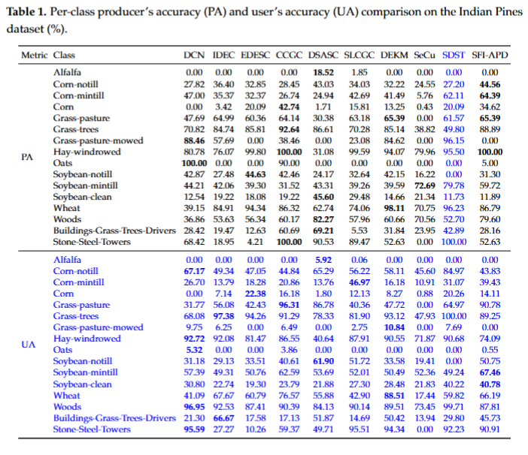
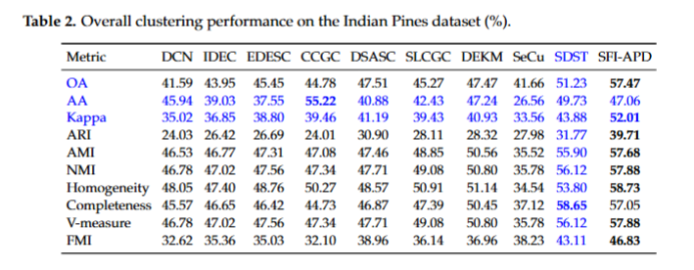
"Table 1 presents the class-wise results, reflecting high Producer's Accuracy (PA) and balanced User's Accuracy (UA) for SFI-APD. Hay-windrowed reaches 100.00% PA, Grass-trees reaches 88.89% PA, Wheat reaches 86.79% PA, and Woods reaches 79.60% PA. In terms of UA, SFI-APD achieves 90.78% for Grass-pasture, 89.25% for Grass-trees, and 87.81% for Woods, indicating reliable predictions for the major vegetation categories.Rare samples in Alfalfa and Oats restrict the cluster-center estimation. Complementing the category-specific observations, the global quantitative evaluations further validate the overall structural consistency.Table 2 shows 57.47% OA, 47.06% AA, 52.01% Kappa, 39.71% ARI, 57.68% AMI, 57.88% NMI, and 46.83% FMI for SFI-APD. Among autoencoder-based baselines, DEKM achieves the highest OA with 47.47%. Among graph and subspace baselines, DSASC gives the highest OA with 47.51%. Among contrastive baselines, SLCGC gives the highest OA with 45.27%. SFI-APD improves OA by 10.00% over DEKM, 12.69% over CCGC, 9.96% over DSASC, and 12.20% over SLCGC. SFI-APD also improves NMI by 7.08% over DEKM and 8.80% over SLCGC. The superior OA, Kappa, and NMI on the Indian Pines dataset validate the effectiveness of HSFIM and FFAB. HSFIM connects separated crop parcels with close spectra through spatial–frequency interaction. FFAB reduces illumination-related amplitude variation and keeps phase-related boundary geometry."
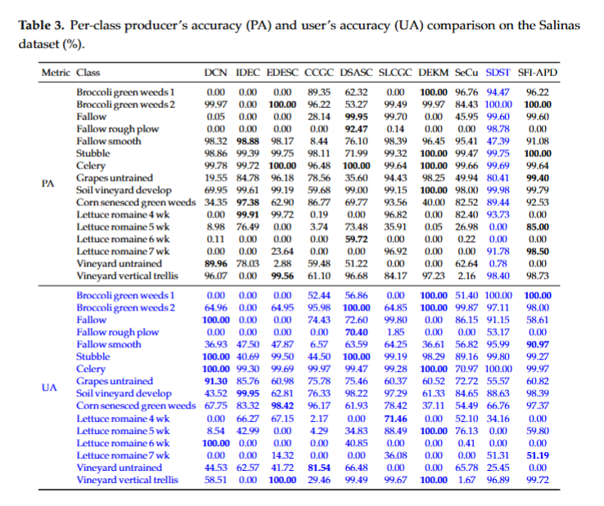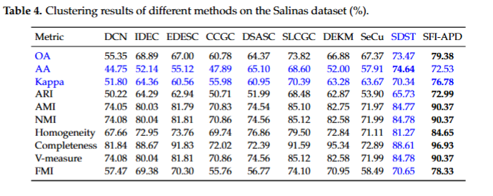
"Table 3 presents the class-wise results, showing high completeness and reliable User's Accuracy (UA) for several large crop fields. Broccoli green weeds 2 and Soil vineyard develop reach 100.00% PA. Fallow, Grapes untrained, Lettuce romaine 5 wk, and Stubble achieve 99.60%, 99.36%, 99.48%, and 100.00% PA . Regarding UA, SFI-APD reaches 100.00% for Broccoli green weeds 1 and over 98% for Broccoli green weeds 2, Stubble, Celery, Soil vineyard develop, and Vineyard vertical trellis, demonstrating reliable predictions for several major crop categories. Class confusion occasionally occurs among Fallow rough plow, Lettuce romaine 4 wk, Lettuce romaine 6 wk, and Vineyard untrained. Lettuce growth stages share close reflectance and often appear in adjacent areas, leading to merged unsupervised cluster centers. Despite localized confusion among spectrally similar classes, the global evaluation metrics in Table 4 demonstrate the robust clustering capability of the proposed method. Table 4 shows 79.38% OA, highly competitive AA and Kappa coefficients, 72.99% ARI, 90.37% AMI, 90.37% NMI, and 78.33% FMI for SFI-APD. SLCGC gives the highest baseline OA with 73.82%. SFI-APD improves OA by 5.56%, NMI by 5.25%, and ARI by 4.51% over SLCGC. Among autoencoder-based baselines, IDEC reaches 68.89% OA, and DEKM reaches 82.58% NMI. Among subspace and graph baselines, EDESC gives 81.81% NMI, and CCGC gives 60.78% OA. Frequency-domain aggregation provides additional long-range grouping capabilities beyond conventional reconstruction, graph construction, and contrastive pairs."
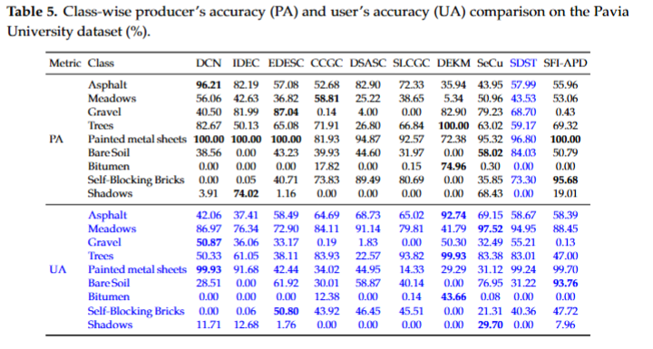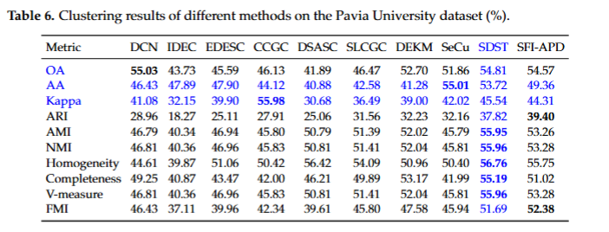
"Table 5 presents the class-wise results, showing 100.00% PA for Painted metal sheets and 95.68% PA for Self-Blocking Bricks, while Bare Soil reaches 50.79% PA. For UA, SFI-APD achieves 99.70% for Painted metal sheets, 93.76% for Bare Soil, and 88.45% for Meadows, indicating high prediction precision for these urban categories.Multi-scale embedding describes repeated urban texture, and FFAB keeps boundary geometry during amplitude–phase reconstruction. Gravel, Bitumen, and Shadows show class confusion because road-like materials and shadowed surfaces have close spectral responses and local context. Beyond the analysis of specific urban materials, the global metrics provide a comprehensive evaluation of the overall clustering stability.Table 6 shows 54.57% OA, competitive AA and Kappa, 39.40% ARI, 53.26% AMI, 53.28% NMI, 53.28% V-measure, and 52.38% FMI for SFI-APD. DCN obtains the highest OA with 55.03% because matched clusters cover several dominant Asphalt and Meadows regions. SFI-APD obtains higher ARI and FMI than DCN by 10.44% and 5.95%, respectively, and maintains stable agreement in Kappa. Higher pairwise metrics indicate more consistent grouping for smaller urban materials and shadow-affected areas. SDST obtains the highest Homogeneity with 56.76%, and the corresponding 46.21% Completeness indicates the fragmentation of several reference classes. Overall, the balanced evaluation metrics confirm the capability of SFI-APD to maintain structural consistency in complex urban environments."
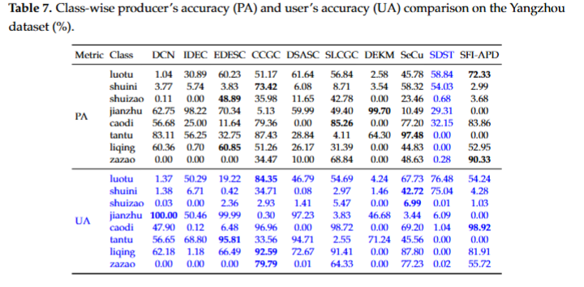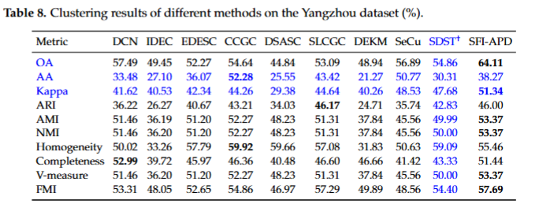
"To illustrate the performance on individual categories, Table 7 shows the quantitative clustering accuracy for the Yangzhou dataset. Table 7 reports high PA and balanced UA on luotu, caodi, and zazao. Decreased PA on shuini, shuizao, jianzhu, and tantu indicates spectral mixing between roads, buildings, tidal flats, and water-related surfaces. The complex spectral mixing explains the higher clustering difficulty of the Yangzhou dataset compared to agricultural scenes with regular parcels. Despite the inherent challenges of spectrally similar surfaces, the proposed method demonstrates strong global stability.From Table 8, SFI-APD achieves higher performances on the Yangzhou dataset compared with the other representative baselines. Table 8 shows 64.11% OA, stable AA and Kappa, 53.37% AMI, 53.37% NMI, 53.37% V-measure, and 57.69% FMI for SFI-APD. Specifically, among autoencoder-based clustering methods, DCN gives the highest baseline OA with 57.49%. Compared with DCN, SeCu, and CCGC, SFI-APD incorporates advanced spatial–frequency aggregation to achieve better clustering performance. SFI-APD improves OA by 6.62%, 7.22%, and 9.47%, respectively. SFI-APD also improves NMI and FMI by 1.91% and 4.38% over DCN, confirming the capability to handle complex urban and water-related scenes."
Comments 6: Compared with recent models such as the Fuzzy Hyperbolic Hypergraph Convolutional Fusion Network and DNMFNet, the accuracy of this method is much lower. Please add SOTA methods from the past two years to verify the advanced nature of the model.
Response 6: Thank you very much for your valuable comment. We agree that comparisons with recently published state-of-the-art methods are important for demonstrating the effectiveness and competitiveness of the proposed model.
We would first like to clarify that the two methods mentioned by the reviewer address a different task and follow a different label-usage protocol from that of our method. The Fuzzy Hyperbolic Hypergraph Convolutional Fusion Network, denoted as FH²GCN, is designed for hyperspectral image classification under limited labeled samples. Its network is optimized using labeled training samples, and its reported accuracy is therefore classification accuracy obtained under a label-guided setting[1]. DNMFNet learns its hierarchical feature extractor in an unsupervised manner; however, the extracted features are subsequently used in a classification framework with limited labeled samples[2]. Consequently, the final accuracy reported by DNMFNet also benefits from category supervision during downstream classification.
In contrast, the proposed SFI-APD is developed for self-supervised hyperspectral image clustering. No ground-truth category labels are used to train the feature extractor, optimize the cluster centers, or generate the cluster assignments. The reference labels are used only after clustering for optimal one-to-one matching between clusters and classes and for calculating OA, ARI, NMI, FMI, and the other evaluation metrics. Following the standard experimental protocol for HSI clustering, the number of clusters is set to the number of reference classes, but the pixel-level category labels are not involved in network optimization. Therefore, directly comparing the classification accuracies of FH²GCN and DNMFNet with the clustering accuracy of SFI-APD would not constitute a methodologically fair comparison.
To provide a fair evaluation of the model's superiority, we included two recent state-of-the-art self-supervised clustering methods, namely SDST (2024)[3] and SLCGC (2025)[4], as baselines. As shown in Tables 1--8, SFI-APD achieves overall accuracies (OAs) of 57.47%, 79.38%, 54.57%, and 64.11% on the Indian Pines, Salinas, Pavia University, and Yangzhou datasets, respectively. Compared with SDST, our method improves the OA by 6.24%, 5.91%, and 9.25% on Indian Pines, Salinas, and Yangzhou, respectively, while maintaining a comparable OA and yielding higher ARI and FMI on Pavia University. Furthermore, SFI-APD consistently outperforms SLCGC, providing OA improvements of 12.20%, 5.56%, 8.10%, and 11.02% across the four respective datasets. Overall, SFI-APD delivers average OA gains of 5.29% over SDST and 9.22% over SLCGC, demonstrating its superior performance under identical self-supervised clustering settings.
References:
[1] Y. Chu, C. Yan, J. Peng, W. Ding, and P. Li, “Fuzzy hyperbolic hypergraph convolutional fusion network for hyperspectral image classification under limited samples,” Information Fusion, vol. 135, Art. no. 104375, 2026, doi: 10.1016/j.inffus.2026.104375.
[2] W. Cui, C. Cheng, H. Li, and Y. Cun, “DNMFNet: Unsupervised deep feature extraction for hyperspectral image classification with limited labels,” Pattern Recognition, vol. 179, Art. no. 113663, 2026, doi: 10.1016/j.patcog.2026.113663.

[3] F. Luo, Y. Liu, Y. Duan, T. Guo, L. Zhang, and B. Du, “SDST: Self-supervised double-structure Transformer for hyperspectral images clustering,” IEEE Transactions on Geoscience and Remote Sensing, vol. 62, pp. 1–14, 2024, doi: 10.1109/TGRS.2024.3374597.
[4] Y. Ding, Z. Zhang, A. Yang, Y. Cai, X. Xiao, D. Hong, and J. Yuan, “SLCGC: A lightweight self-supervised low-pass contrastive graph clustering network for hyperspectral images,” IEEE Transactions on Multimedia, vol. 27, pp. 8251–8262, 2025, doi: 10.1109/TMM.2025.3604954.
Location in the Revised Manuscript
Section 2.2, “Vision Transformer,” in the Related Work section, specifically the final paragraph of this subsection, immediately before Section 3, “Method.”
Revised Manuscript Text
“Frequency-domain and wavelet-based ViT architectures present an alternative paradigm for efficient token mixing. AFNO employs adaptive Fourier-domain token mixing for high-resolution Vision Transformers via block-diagonal channel mixing, adaptive weight sharing, and sparse frequency modes.[16] Wave-ViT integrates wavelet transforms into Vision Transformer attention, leveraging invertible key-value downsampling to retain high-frequency texture details[17]. SpectFormer couples spectral layers with multi-head attention[18] ; these spectral layers project image tokens into the Fourier domain, apply learnable gates, and reconstruct spatial tokens via inverse Fourier transforms. Earlier Fourier token mixers, such as FNet, substitute self-attention with parameter-free Fourier transforms[38] , whereas GFNet formulates global frequency filters to capture long-range spatial dependencies[39] . DCT-based attention leverages frequency decorrelation and high-frequency component truncation to mitigate computational overhead[40] , whereas FFTformer-FSAS approximates scaled dot-product attention via element-wise multiplication in the frequency domain[41].
In contrast to approaches dependent on global spectral filtering or frequency-component truncation, FreqViT explicitly calculates input-adaptive query-key correlations through normalized cross-spectrum modulation. The mechanism retains essential token dependencies while circumventing the $O(N^{2})$memory overhead associated with dense N$×$N affinity matrices. Furthermore, although existing models are predominantly optimized for generic visual recognition or supervised image restoration, they fail to account for the amplitude-phase characteristics critical for illumination-robust HSI clustering.“

References:
[16]J. Guibas, M. Mardani, Z. Li, A. Tao, A. Anandkumar, and B. Catanzaro, “Adaptive Fourier neural operators: Efficient token mixers for Transformers,” in Proc. International Conference on Learning Representations (ICLR), 2022.
[17] T. Yao, Y. Pan, Y. Li, C.-W. Ngo, and T. Mei, “Wave-ViT: Unifying wavelet and Transformers for visual representation learning,” in Proc. European Conference on Computer Vision (ECCV), 2022, pp. 328–345.
[18] B. N. Patro, V. P. Namboodiri, and V. S. Agneeswaran, “SpectFormer: Frequency and attention is what you need in a Vision Transformer,” in Proc. IEEE/CVF Winter Conference on Applications of Computer Vision (WACV), 2025, pp. 9543–9554.
[38] J. Lee-Thorp, J. Ainslie, I. Eckstein, and S. Ontanon, “FNet: Mixing tokens with Fourier transforms,” in Proc. NAACL, 2022, pp. 4296–4313.
[39] Y. Rao, W. Zhao, Z. Zhu, J. Lu, and J. Zhou, “Global filter networks for image classification,” in Advances in Neural Information Processing Systems, vol. 34, 2021, pp. 980–993.
[40] H. Pan, E. Hamdan, X. Zhu, K. Biswas, A. E. Cetin, and U. Bagci, “DCT-based decorrelated attention for vision Transformers,” arXiv preprint arXiv:2405.13901, 2024.
[41]L. Kong, J. Dong, J. Ge, M. Li, and J. Pan, “Efficient frequency domain-based Transformers for high-quality image deblurring,” in Proc. IEEE/CVF Conference on Computer Vision and Pattern Recognition (CVPR), 2023, pp. 5886–5895.

Comments 7: The Conclusion should include the limitations of this study and the next steps for future research.
Response 7: Thank you very much for your constructive suggestions for the conclusion section. Discussion of study limitations and future work is indeed missing in the original manuscript, which we have supplemented in the revised manuscript. At the end of the conclusion, we point out the current limitation of the SFI-APD framework: in the unsupervised clustering center iteration process, the model may still confuse rare categories, small objects and some ground objects with highly similar spectral features. At the same time, we also clarify the future research directions, which mainly include the adaptive estimation of the number of clusters, the self-supervised constraint of edge information, and the fusion of multi-modal features. In addition, to avoid redundancy, we have moved the limitation analysis from the original discussion and integrated it into the conclusion.
Location in the Revised Manuscript
Section 6, Conclusions, final paragraph.
Revised Manuscript Text
“Although SFI-APD has achieved excellent clustering performance, certain limitations remain in complex terrain analysis. During the iterative optimization of clustering centers, SFI-APD shows limited capability in identifying minority classes, small-scale targets, and highly similar spectral features. Misclassification often occurs in areas with strong spectral similarity, such as alfalfa and oats in the Indian Pines dataset, as well as lettuce at different growth stages in the Salinas dataset. Meanwhile, complex scene spatial topology reduces the clarity of local clustering boundaries. This issue is especially evident in the shadow areas of the Pavia University dataset and the water–land junction areas of the Yangzhou dataset.
To address these issues, future work will explore adaptive cluster number estimation to reduce dependence on prior hyperparameters. Boundary-aware self-supervised constraints will also be introduced to better separate fine-grained neighboring regions. In addition, multi-source remote sensing data, such as LiDAR, will be used for cross-modal interaction to enhance feature edges between spectrally similar materials and improve overall clustering robustness.”

